“Early reading, whether it is in a parent’s lap, on the carpet of a classroom, or in a snug reading corner, gently but indelibly imprints upon us the mould from which will cast a lifetime of communication in the world.”
Alex Quigley – Closing the Reading Gap 2020.
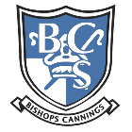

Welcome to the Bishops Cannings Reading Spine.
This reading spine links with our whole school Literacy intent, where during your children’s time at Bishops Cannings they will:

- Receive a high quality curriculum within a literacy rich environment
- Experience a diverse range of texts and have a love of reading
- Able to confidently communicate with others
- Develop independence in their writing skills across a range of genres
Selecting the books for our reading spine is a deliberate process aimed at fostering a love for reading while aligning with educational objectives. As stated by the National Literacy Trust, “Reading for pleasure is the single most important indicator of a child’s future success.”
Our chosen texts serve multiple purposes:
- Curriculum Alignment: Each book is selected to complement the national curriculum, ensuring that children engage with literature that enhances their learning experience.
- Interest and Engagement: We prioritise books that capture the interests of our children, promoting a culture of reading that resonates with all learners.
- Reducing the Gender Gap: The selection includes titles that appeal to all genders, addressing the disparity in reading engagement among boys and girls.
- Significant Individuals: We include works that highlight the contributions of significant individuals, encouraging students to learn about diverse role models.
- Values and Teachings: We have included a selection of texts from the magazine ‘Discovery RE.’ These texts reflect the teachings of Jesus, promoting our school values – thankfulness, generosity, aspiration, perseverance, graciousness and wisdom which enables flourishing for all.
- ‘Just Reading’ session: the books within our reading spine are integral to our ‘Just Reading’ sessions, providing a consistent and enriching reading experience that supports literacy development across the school.

EYFS
Autumn 1 | Autumn 2
  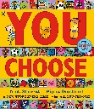  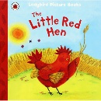  My Body by Discovery World  My Special Angels (I) All Are Welcome (Hum) Creation Story | 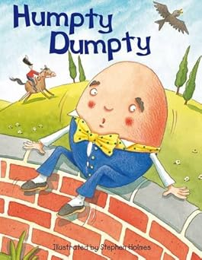  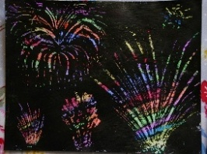  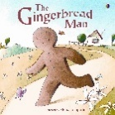  Bonfire Poetry  Nursey Rhymes  - Head Shoulders Knees & Toes,  - Number Rhymes (1 finger, 1 thumb – 2 little dicky birds)  - Triangle Song  - Hickory Dickory  - Firework Poem  Big Book of Celebrations  The Birth of Jesus
Discover Good News Magazines – RW link  Genesis 1: The beginning  What do you think the best thing about creation is in the story? (P. 4/5) | Discover Good News Magazines – RW link  Luke 1: 26-38  The birth of Jesus  Have you ever seen a nativity or performed in one? What part is your favourite part? (p. 37)
Spring 1 | Spring 2
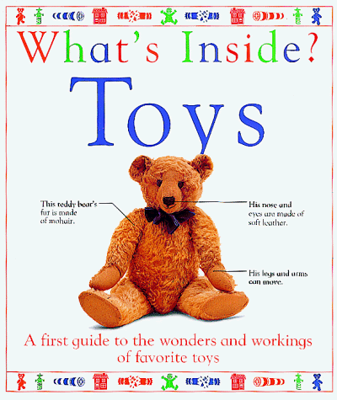  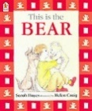  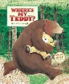  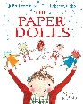  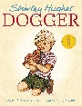  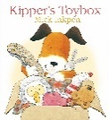 | 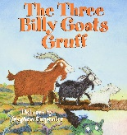  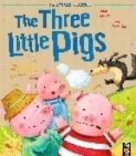  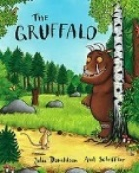  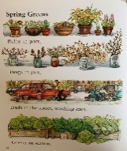  A selection of rhymes linking to Spring. Spring Greens- Shirley Hughes  People Need People (Hum) Palm Sunday
Discover Good News Magazines – RW link  Exodus 20: 1-21  Look at the Ten Commandments (Age appropriate) . Do they know what any of them mean? (p.27) | Discover Good News Magazines – RW link  Matthew 21: 1-11  Jesus Enters Jerusalem like a king  The crowds welcomed him like a king and waved palm leaves. How would you have felt if you had been there? (P. 60)
Summer 1 | Summer 2
  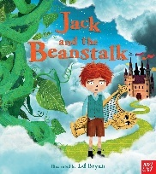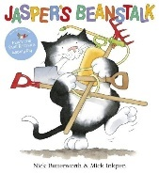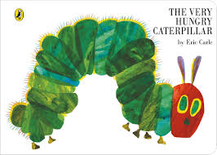  The Life Cycle of a Butterfly Bean diary/sunflowers  Butterfly by David L Harrison  Georgia O’Keefe Jesus at the temple | 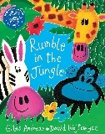  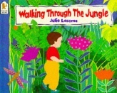  Life in the Rainforest (Topic)  David Attenborough Conversation with Paul
Discover Good News Magazines – RW link  Luke 2:41-51  Jesus at the Temple  Why were Jesus’ parents worried? (P. 44) | Discover Good News Magazines – RW link  Acts 9: 1-21  The conversion of Paul  When Saul was blinded by the light he saw on his way to Damascus, what do you think he thought about? (P. 80)

Year 1
Autumn 1 | Autumn 2
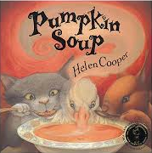  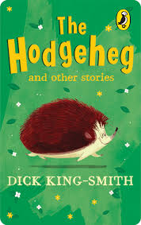  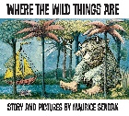  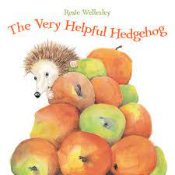  The Gunpowder Plot – selection of information texts |   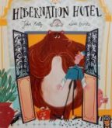  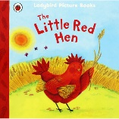  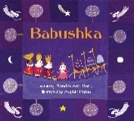  The More it Snows – AA Milne (Poem)
Discover Good News Magazines – RW link  Adam and Eve It’s a Mitzvah (J) | Discover Good News Magazines – RW link  The Magi
Spring 1 | Spring 2
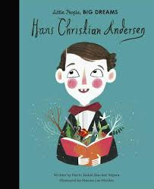  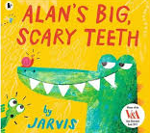  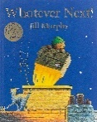  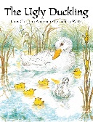  Birds (a selection of non-fiction texts)  The History of Flight – The Wright Brothers (a selection of non-fiction texts) | 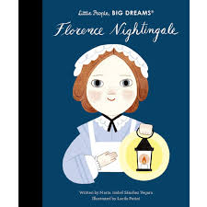  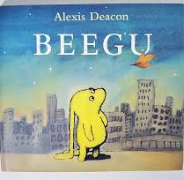  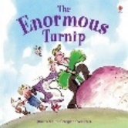    A selection of spring poetry (Daffodils)  Sunflower/Cucumber – Diary extracts
Discover Good News Magazines – RW link  10 Commandments | Discover Good News Magazines – RW link  The cleansing of the temple
Summer 1 | Summer 2
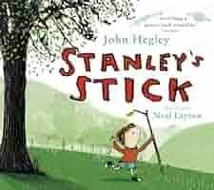  Queen Victoria – a selection of non-fiction texts | 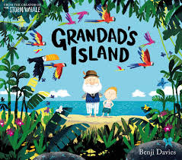  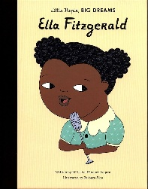  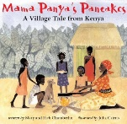  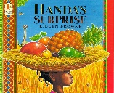  African Animals (Selection of Non-Fiction Texts)
Discover Good News Magazines – RW link  Jesus begins healing | Discover Good News Magazines – RW link  The Conversion of Paul

Year 2
Autumn 1 | Autumn 2
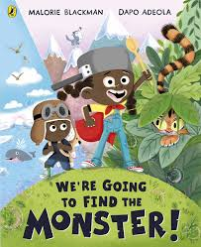  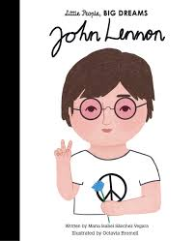  Great Fire of London poem  Molly Malone and the Great Fire of London  Great Fire of Lonon – Non Fiction texts | 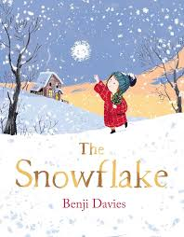  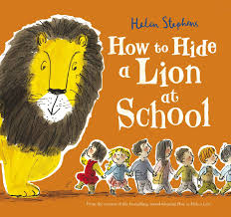  Nativity – Playscript  The More it Snows – AA Milne poem
Discover Good News Magazines – RW link  The Beginning (Adam and Eve) | Discover Good News Magazines – RW link  The Shepherds and the Angels  Oskar and the Eight Blessings (J)
Spring 1 | Spring 2
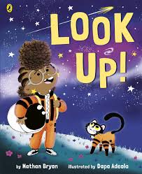  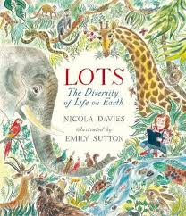  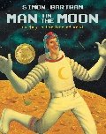 | 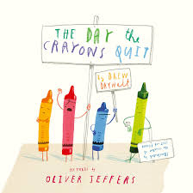  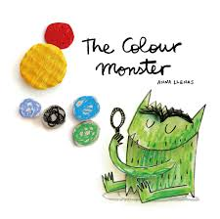  The Owl and the Pussy Cat – Poem
Discover Good News Magazines – RW link  10 Commandments | Discover Good News Magazines – RW link  Cleansing of the Temple
Summer 1 | Summer 2
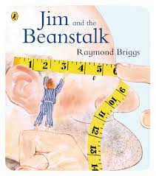  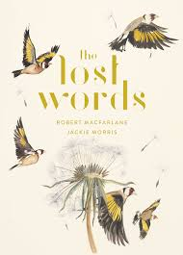  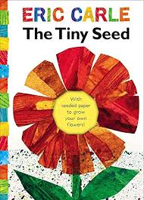 | 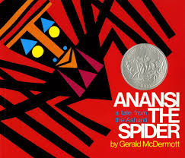  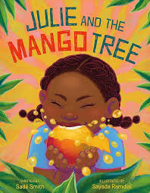  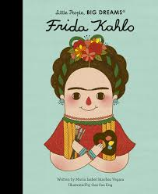  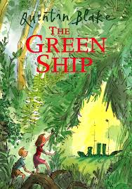  Don’t – Michael Rosen Poetry

Year 3
Autumn 1 | Autumn 2
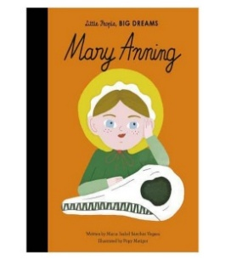  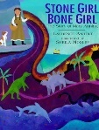  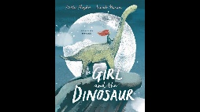  Laila’s Lunchbox (I) Temptation and the Fall | 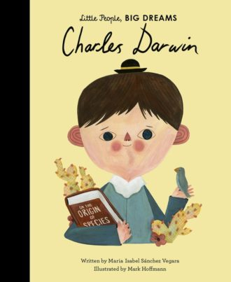  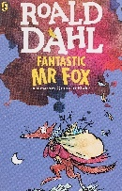  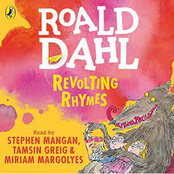  The Magi
Discover Good News Magazines – RW link  Genesis 3:  Temptation and the fall  What happened because Adam and Eve broke the rules? What do you think the story means? (p.8) | Discover Good News Magazines – RW link  Matthew: 2: 1-12  The Magi visit the Messiah  Read the extract. What do you think the gifts symbolised that they bought for Jesus? (p. 42)
Spring 1 | Spring 2
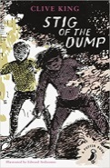  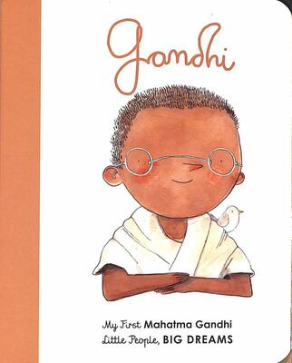  Mahatma Ghandi  A selection of instructional texts.  Mrs Homophone. Range of other poetry. | 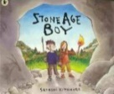  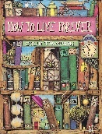  How to Live Forever – Colin Thompson DK Find Out: Stone Age  A selection of kennings poetry.
Discover Good News Magazines – RW link  Proverbs 6: 16- 19  Read the passage. It states the 7 things God hates. Do you agree that God hates these things? What are your thoughts? (p. 29) | Discover Good News Magazines – RW link  John 13: 1-11  Washing his Disciples’ feet  Why was Peter embarrassed to have his feet washed by Jesus? What lesson did Peter learn? (P. 62)
Summer 1 | Summer 2
  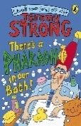  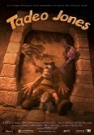  Tadeo Jones There’s a Pharoah in our Bath  A selection of simile poetry. | 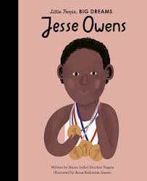  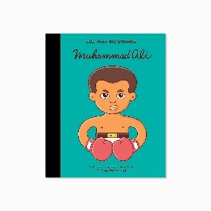  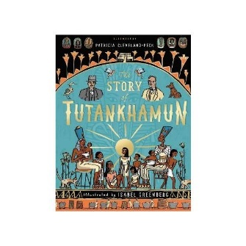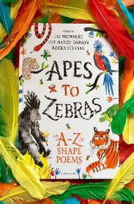
Discover Good News Magazines – RW link  Matthew 8:23-27  Jesus calms the storm  The disciples ask: what kind of man is this? What do you think is the answer? Give reasons.  (P. 51) | Discover Good News Magazines – RW link

Year 4
Autumn 1 | Autumn 2
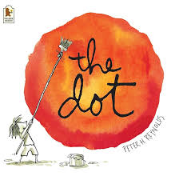  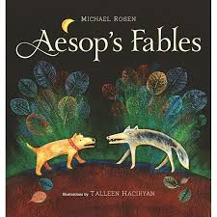  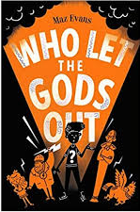  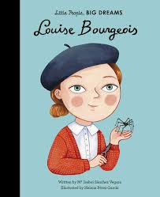  A Selection of Olympics texts | 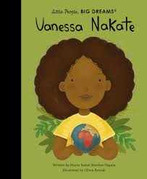  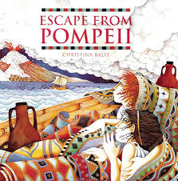  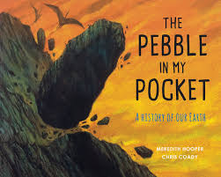  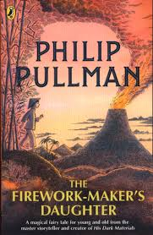  A selection of Christmas Adverts  Christmas poetry  Information and explanation reports on natural disasters
Discover Good News Magazines – RW link  Abraham and Sarah | Discover Good News Magazines – RW link  Jesus born in Bethlehem
Spring 1 | Spring 2
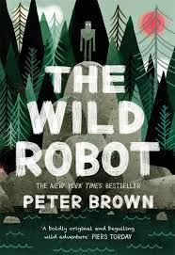  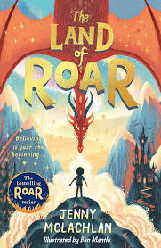  Non-fiction texts about The Romans | 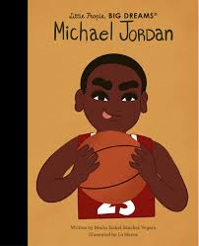  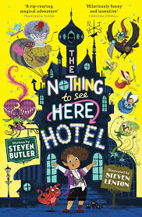  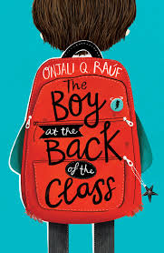  Chocolate Cake – Michael Rosen Poetry  Non-fiction texts about settlements
Discover Good News Magazines – RW link  Psalm 23 What is God like | Discover Good News Magazines – RW link  Last Supper and the arrest in Gethsemane
Summer 1 | Summer 2
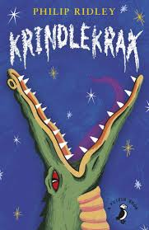  Non-fiction texts about the Anglo-Saxons | 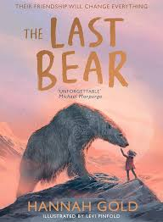  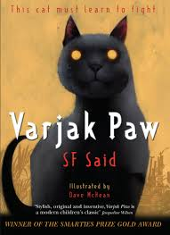  The Sound Collector Poem
Discover Good News Magazines – RW link  Jesus teaches his first followers | Discover Good News Magazines – RW link  New Testament writers explain Christian belief about God

Year 5
Autumn 1 | Autumn 2
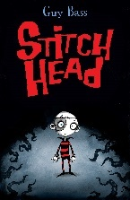  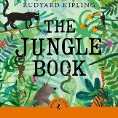  Stitch Head  Jungle Book  Coming to England by Floella Benjamin  Migration-open hearts, open borders by Shaun Tan  Little People, Big Dreams  Stephen Hawking  Albert Einstein  Mary Shelley | 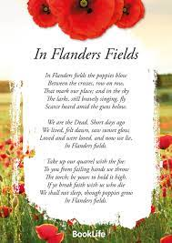  Don’t Be Scared’ by Carol Ann Duffy  ‘I Wandered Lonely as a Cloud’ By William Wordsworth  ‘Betty’s Room’ by Denise Rogers  Let’s Give a Cheer for Onomatopoeia’ by John Foster  Firework Night’ by Enid Blyton  ‘Winter’ by Judith Nicholls  ‘I am Brave’ by Laura Mucha  One-minute timer, ‘The World’s Fastest Bicycle’ by Kenn Nesbitt  Lighthouse Poetry (LS Figurative Language Poem)  In Flanders Fields  The Creakers by Tom Fletcher  My Dadima Wears a Sari (H)  Why God came into the World
Discover Good News Magazines – RW link  Genesis & Hebrews: 11  Faith in God  What do these stories teach us about what God is like? Why do you think the idea of ‘trust’ or ‘faith’ in God is given such a big part in these stories? (p.12 &13) | Discover Good News Magazines – RW link  John 1: 1-14  Why God came into the world.  In John’s Gospel, he teaches that ‘the Word became flesh, full of grace and truth’. What do you understand by this statement? (P. 43)
Spring 1 | Spring 2
  A selection of letters.  A selection of Newspapers.  The Story of the Titanic for children by Joe Fullman  David Attenborough Little People Big Dreams by Maria Isabel Sanchez Vegara and Mikyo Noh (Autobiography)  Poetry  I am a writer  By Joseph Coelho | 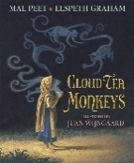  Cloud Tea Monkeys – Mal Peet  Mysterious Traveller
Discover Good News Magazines – RW link  Exodus 19 3-6  Do you remember the word ‘covenant from Year 4? What difference did it make to the people to have a covenant with God? (p. 26) | Discover Good News Magazines – RW link  Luke 22: 66-71 and Luke 23:1-5  Jesus is put on trial  What could Pilate have done instead of condemning Jesus? Why do you think his enemies wanted him dead? (P. 65)
Summer 1 | Summer 2
Mia and the Lightcasters by Janelle Mccurdy  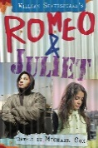  Wallace & Gromit:The Complete Cracking Contraptions Manual: Volumes 1 & 2  by Derek Smith , Graham Bleathman  Shakespeare – The Tempest  Little People, Big Dreams  Nelson Mandela | 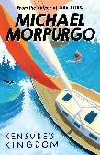  Journey to the Centre of the Earth-Classic Fiction  A selection of poetry about the sea.  Kensuke’s Kingdom  JRR Tolkien  Love in action
Discover Good News Magazines – RW link  The Good Samaritan  Luke 10:25-37  The Good Samaritan  In this story, what is Jesus teaching to His followers? Why do you think this has become one of the most famous sections of the whole Bible? (P. 53) | Discover Good News Magazines – RW link  Romans 12:9-21 and Galatians 3: 26-28  Love in Action  Read these teachings. Can you pick out any you think people especially need to hear today? How would our school/towns be like if everyone followed these ways of life? (P. 90)

Year 6
Autumn 1 | Autumn 2
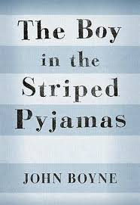  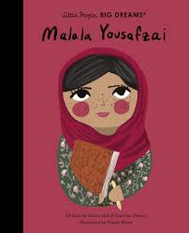 | 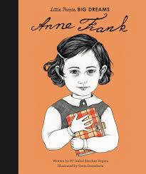  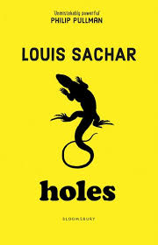  A selection of war and remembrance poetry.  A selection of letters
Discover Good News Magazines – RW link  How can following God bring freedom and Justice | Discover Good News Magazines – RW link  Why God came into the World
Spring 1 | Spring 2
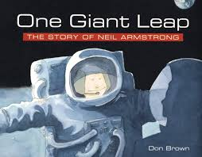  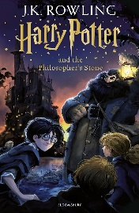  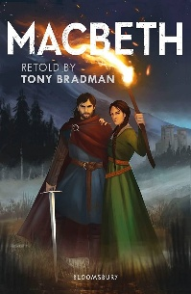  If – Rudyard Kipling  A selection of newspapers  Short reads – VIPERS  One Giant Leap – annotated picture book for writing lessons | 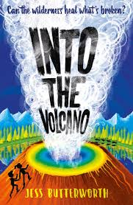  Short reads – VIPERS
Discover Good News Magazines – RW link  10 Commandments | Discover Good News Magazines – RW link  The Crucifixtion/The death/Jesus has risen
Summer 1 | Summer 2
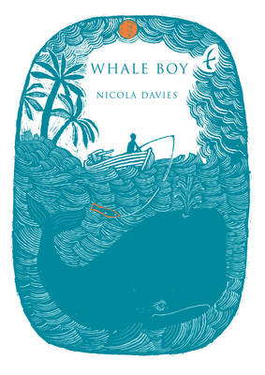  Short reads – VIPERS  A selection of newspapers | Hunger Games  Jabberwocky  A selection of interviews  Playscripts – performance
Discover Good News Magazines – RW link  Jesus teaches his disciples | Discover Good News Magazines – RW link  St Paul teaches Christians about love

