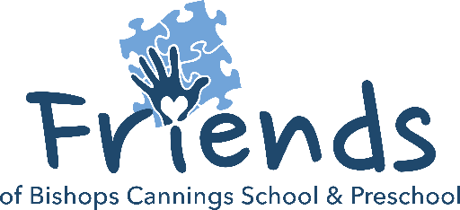
Term 1 is almost over!
The first term is almost over and the friends hope that the new school year has been great for everyone! With new members joining the Friends Committee we have been busy planning our events for the coming year, building on the success of all our events last year, including the Circus workshops, the Christmas snow, the Easter Egg trail, the jumble sales, Mother & Father’s Day pop ups and Christmas craft making workshop to name a few. To get us started we have the return of the Lantern Making Workshop. More fun events to follow once dates have been set.

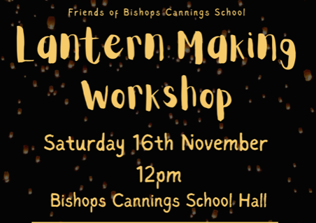
Our Lantern making workshop is a great opportunity to get those creative juices flowing and to showcase our wonderful school around the town. This year’s DOCA theme is “Home is Where the heART Is” and we will have 2 slots available on Saturday 16th November; 12-2pm for beginners with a lead from DOCA, and an experienced session 2-4pm, where you can make them yourself. All lanterns must be taken home at the end of the session as we no longer have any space in school to store them. We will arrange a meet up for the actual parade nearer the time.
The cost will be £5 per lantern, which includes all materials. Due to limited space, we will limit the number of families to 15 per session, so make sure you book and pay as soon as you know you want to come. The forms to book are live on ParentMail now.


At our AGM, our new committee was elected.
If you would like to review the President, Chairperson and Treasurers report, please go to the Schools Website. We also share our minutes of this meeting there.

2024-2025 Committee
Chairperson: Emily Holmes
Treasury Team: Alice Lloyd
Adam Deacon
Secretary: Leonie Freegard

To sweeten up the return to school and also celebrate Bonfire Night our Donut Sale will be coming soon (exact date will be published shortly)
£1 each (Sale at lunchtime and after school by your Friendly Friends)

